Name | Subject Class | Class | Index Number
 | 2BI



ANGLO-CHINESE JUNIOR COLLEGE
H2 Biology Preliminary Examinations 2021

H2 BIOLOGY 9744/04
Practical 12 August 2021
2 hours and 30 minutes

READ THESE INSTRUCTIONS FIRST
Write your name, index number, class, shift and laboratory on this Question Paper.

Shift
Laboratory
Write in dark blue or black pen.
You may use a HB pencil for any diagrams or graphs.
Do not use staples, paper clips, glue or correction fluid.

Answer all questions in the spaces provided on the Question Paper.

For Examiner's Use
1 |  | / 28
2 |  | / 27
Total | 55
The use of an approved scientific calculator is expected, where appropriate. You may lose marks if you do not show your working or if you do not use appropriate units.

The number of marks is given in brackets [ ] at the end of each question or part question.

this question paper consists of 16 printed pages.

Answer all questions.

- Yeast cells contain enzymes which catalyse the breakdown of glucose to produce ethanol and carbon dioxide.

These products change the environment of the yeast cells and can affect their metabolic activity and survival.

The carbon dioxide produced dissolves in the aqueous medium to form a weak acid. Hence the more carbon dioxide released, the more acid will be formed.

- Suggest why the presence of ethanol, a small organic molecule, can affect the survival of yeast cells.

- Ethanol can pass through the phospholipid bilayer of yeast’s cell membrane via diffusion R! transport protein;
- It may cause the denaturation/inhibition of enzymes involved in metabolic activities (such as respiration and binary fission);
- Ethanol can also disrupt the hydrophobic interactions between the phospholipids of the cell membrane;
- Hence, resulting in the lysis of yeast cells;
@ 1m | [2]

You are required to investigate the effect of different concentrations of ethanol on the metabolic activity of yeast cells by measuring the change in pH, using Universal Indicator paper strips.

You are provided with:

- at least 60 cm³ yeast suspension, labelled Y
- at least 15 cm³ ethanol, labelled E
- at least 60 cm³ 20% glucose solution, labelled G
- distilled water

Ethanol is harmful and highly flammable. If any comes into contact with your skin, wash immediately under cold water.

It is recommended that you should wear eye protection.

Keep the ethanol covered when you are not using it.

It is important to determine the pH of the glucose solution and the ethanol before starting the investigation.

Place a strip of the Universal Indicator paper on a white tile.
Using a clean Pasteur pipette, place a drop of glucose solution onto the paper.
Use the colour chart to identify the pH.
Repeat the steps above, after cleaning the Pasteur pipette, to find the pH of ethanol.

(b) (i) Record the pH for both the glucose solution and ethanol in the table below.

Solution | pH
Glucose | 6/7
Ethanol | 5/6
[1]

Clean and dry the white tile before proceeding with the rest of the procedure.

You are going to vary the independent variable, the concentration of ethanol.

Table 1.1 shows how to prepare two of the concentrations you should use. These two concentrations are the lowest and highest concentrations that need to be prepared.

Table 1.1

percentage concentration of ethanol | volume of ethanol / cm³ | volume of distilled water / cm³
0 | 0.0 | 10.0
40 | 4.0 | 6.0

(ii) Using the information in Table 1.1, decide which other ethanol concentrations to prepare and complete Table 1.2. Include the ethanol concentrations from Table 1.1.

Table 1.2

tube number | percentage concentration of ethanol | volume of ethanol / cm³ | volume of distilled water / cm³
1 | 40 | 4.0 | 6.0
2 | 30 | 3.0 | 7.0
3 | 20 | 2.0 | 8.0
4 | 10 | 1.0 | 9.0
5 | 0 | 0.0 | 10.0

- Correct final 5 concentrations (to accept only 0-40%);
- Correct volumes of ethanol and distilled water used for each concentration;
- Precision of data (1 d.p. for volume and whole number for ethanol concentration);
[3]

- Label 5 boiling tubes 1 to 5.

- Adding the water before the ethanol, use the syringes provided to make up the ethanol concentrations in the correct boiling tubes.

- Use a clean 10 cm³ syringe to put 10 cm³ of the yeast suspension into each tube.

- Use the beaker provided to make a water bath with warm water between 45 °C and 50 °C.

- Shake the tubes carefully to thoroughly mix the ethanol and water.

- Place the tubes into the warm water and leave them for at least 5 minutes.

- Use the marker pen provided to label the white tile as shown in Fig. 1.1.

- Arrange two rows of the Universal Indicator paper strips on the white tile as shown in Fig. 1.2.
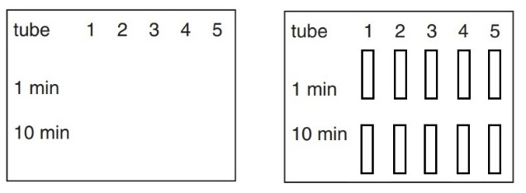
Universal indicator paper strips

Fig. 1.1 Fig. 1.2

- After the tubes have been in the water bath for at least five minutes, start a stopwatch.

- Use a clean 10 cm³ syringe to put 10 cm³ of the glucose solution into each tube starting with tube 1.

Each time shake the tube well and return it to the warm water bath.

- When the stopwatch shows one minute, use the glass rod to remove a drop from the contents of tube 1 and place the drop onto the correct Universal Indicator paper strip.

- Clean the glass rod and use it to remove a drop as described in step 11 from the other four tubes.

- When the stopwatch shows 10 minutes, use the glass rod to take further drops as described in step 11.

(iii) Prepare the space below and record the pH corresponding to the colour of each Universal Indicator paper strip.

Percentage concentration of ethanol | pH
Percentage concentration of ethanol | After 1 minute | After 10 minutes
40 | 7 | 7
30 | 6 | 6
20 | 5 | 5
10 | 4 | 4
0 | 4 | 3

  - Table layout: independent variable (percentage concentration of ethanol) to occupy leftmost column;
  - Appropriate column headings;
  - Precision for data (A! pH values that are halfway between whole numbers e.g. 6.5);
  - Complete set of data (for both 1st and 10th mins)+ correct trend (greatest yeast activity in tube with 0% ethanol denoted by the lowest pH for both 1st and 10th mins);
[4]

(c) (i) Identify two significant sources of error in this investigation.
- Difficulty in judging colour/matching exact colours to colour chart/colours are very close together/colours observed are not observed on colour chart;
- Difficulty in maintaining a constant temperature of the water bath;
- Evaporation of ethanol solution as test tubes are not sealed;

4. Difficulty in properly timing the tubes at the first and tenth minute (idea of staggering is challenging);
AVP: Some carbon dioxide gas is lost to the surroundings instead of dissolving;  R! reaction time  @ 1m | [2]

(b) (ii) Syringes were used to measure the volumes of ethanol and distilled water.
State the volume of the smallest division on the syringe | 0.2 cm³
State the degree of uncertainty | 0.1 cm³ | [1]

(d) Using the relevant information provided, design an experiment that will allow you to determine the lowest concentration of ethanol that will result in zero metabolic activity of yeast cells. You should use a method, other than the one described above.

You should make use of the following apparatus:

- 500 cm³ glass beaker
- Boiling tube
- Delivery tube

You may use the space given below to draw your proposed experimental set-up if required.

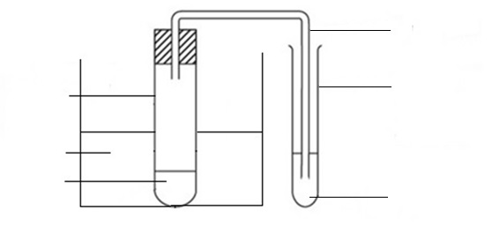
Delivery tube
Fixed volume of yeast solution with ethanol + fixed volume of glucose solution
Water bath
Boiling tube
Water
Test tube

- Appropriate set-up described/ drawn with apparatus labels, with the use of the apparatus stated (beaker, boiling tube, delivery tube and test tube with distilled water/gas syringe); A! delivery tube connected to gas syringe
- Use of at least 5 concentrations of ethanol with appropriate range
(based on SS’s results: highest concentration used can be 40% or above 40%);
- Set up a water bath in a beaker, using a mixture of hot and cold water and check the temperature using a thermometer; R! thermostatically controlled water bath
- Use fixed temperature for water bath (range falling between 45 °C and 50 °C);
- Use a fixed volume/concentration of yeast solution;
- Use a fixed volume of ethanol;
- Use a fixed volume/concentration of glucose concentration;
- DV is counting the number of bubbles formed / volume of gas collected in a fixed amount of time using a stopwatch;
- *Determination of lowest ethanol concentration by drawing a graph of rate of respiration (y-axis) against ethanol concentration (x-axis) and obtaining the intersection with the x-axis / x-intercept where rate of respiration is 0;
*Compulsory point  To mark for points 4-7 if they are annotated clearly in the diagram;  Points 3-7 (constant variables) max 2  @ 1m, max 5 | [5]

(e) In a similar investigation, a student made up different masses of dried yeast into a suspension with 10% glucose solution and measured the percentage of light absorbed by the suspension. The results of the student’s investigation are shown in Table 1.3.

Table 1.3

Mass of dried yeast / g 100 cm^{–3} glucose solution | Mean percentage absorbance
1.00 | 9
1.50 | 17
2.00 | 39
2.25 | 53
3.00 | 94


(b) (i) Plot a graph of the data in Table 1.3.
2.50
1.50
0.50
3.00

2.00
1.00
0.00
Mean percentage absorbance
0
20
40
100
60
80
X
X
X
X
X

Mass of dried yeast / g 100 cm^{–3} glucose solution

- Independent variable is at x-axis (Mass of dried yeast) + both axes correctly labelled (follow the table headers provided);
- Appropriate scale: graph is at least 50% of grid and intervals are equidistant and interval markings must be shown;
- Points plotted accurately, within half of a small square;
- Best fit curve/straight line with no extrapolation;
[4]

The student then investigated the growth of yeast which has been treated with a particular concentration of ethanol over a period of time. The dry mass of 1.50 g of yeast in 100 cm³ glucose solution has an absorbance of 17%. He measured the percentage absorbance after one day and after three days. The first result is shown in Table 1.4.

Table 1.4

time/ days | mean percentage absorbance | Mass of yeast / g 100cm⁻³ glucose solution
0 | 17 | 1.50
1 | 60 | 2.40 (A! 2.35 – 2.43)
3 | 25 | 1.70 (A! 1.70 – 1.75)

(ii) Complete Table 1.4 using the graph. [1]
Answers must be to 2 d.p. as in table;

(iii) Show clearly on the graph how you obtained the mass of dried yeast after one day. Put your answer on the graph that you have plotted. [1]
Need to have both vertical and horizontal lines clearly indicated on graph for after one day;

(iv) Based on the student’s observations, he made the hypothesis that:

There will be a higher mass of yeast in the culture after two days compared to day 1.

State whether this hypothesis is supported by the student’s results. Explain your answer.
- No;
- There is a decrease in the mass of yeast from day 1 (2.40 g 100 cm⁻³ glucose solution) to day 3 (1.70 g 100 cm⁻³ glucose solution) hence it is possible that there is a lower mass of yeast on day 2;
- Yes;
- There is an increase in in the mass of yeast from day 0 (1.50 g 100 cm⁻³ glucose solution) to day 1 (2.40 g 100 cm⁻³ glucose solution) hence it is likely that there is a higher mass of yeast on day 2;
@ 1m | [2]

(v) Discuss whether the above method used by the student in (e) provides an accurate measurement of the growth of yeast.

Yes
- A high absorbance reading correlates with high number of yeast cells, indicating that there is an increase in the number of yeast cells;
No
- The culture can contain a large proportion of dead/lysed yeast cells which will contribute to (high) absorbance reading;
- Yeast suspension will settle over time, leading to inaccurate measurement of absorbance;
@ 1m |  | [2]

[Total: 28]

- In this section, you will require access to a microscope.

Specimen F is the fruit of a common plant. Use the knife provided to cut the fruit in half as shown in Fig. 2.1.

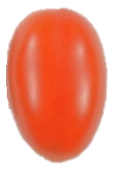

Cut along this line

Fig. 2.1

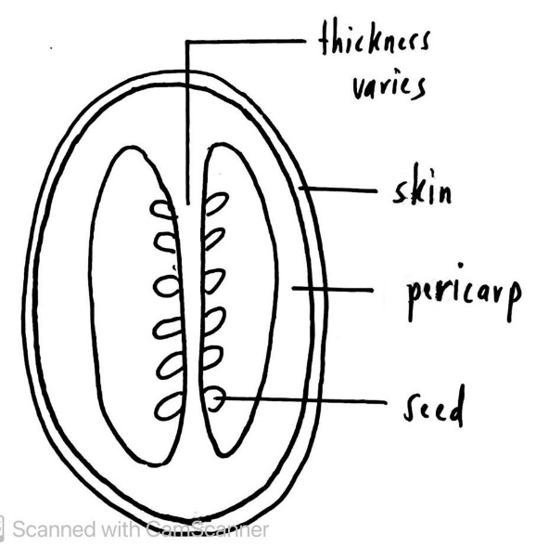
(a) (i) Use the space provided to draw a large plan diagram of the cut surface of the fruit. Labels are not required. [4]

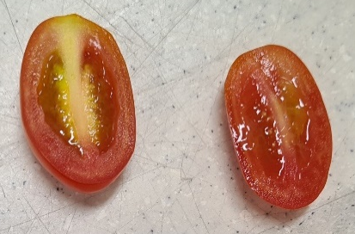

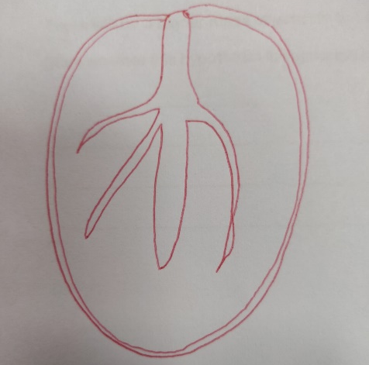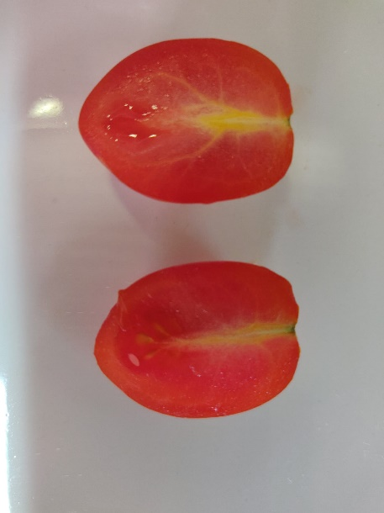

1. | Accuracy | Correct proportions of regions;
2. | Accuracy | Show all the structures that can be seen (skin, pericarp and placenta);
3. | Clarity | Use of sharp pencil to draw clear single neat lines;
4. | Scale | Use at least 2/3 of space provided;

(ii) Take the fruit and scrape some flesh from under the skin.

Place a small quantity of the flesh on a microscope slide. Add a drop of water.

Add a coverslip to the slide, lightly squashing the tissue, taking care to trap as few air bubbles as possible.

Use a paper towel to absorb any excess liquid.

Use your microscope, with an appropriate objective lens, to observe the cells.

Make a large labelled drawing of three cells. [4]
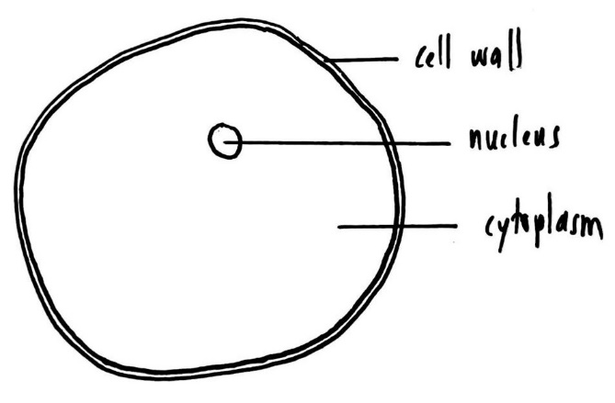

Drawing of one cell

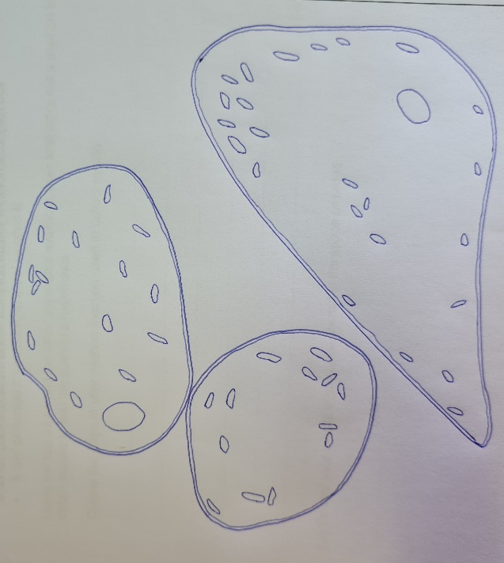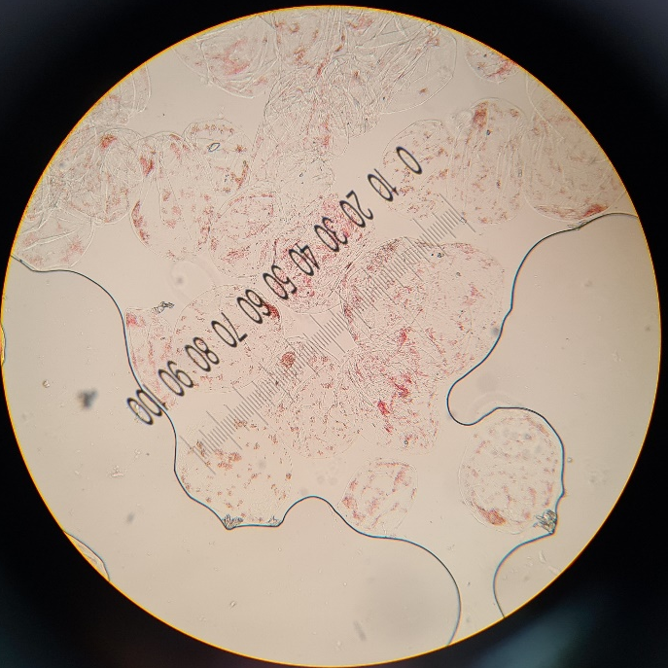

1. | Accuracy | - Correct proportions and orientation - correct shape + three cells R! rectangular  - show all the structures that can be seen in the defined part of the specimen; Cell wall, cytoplasm, at least one cell with nucleus, pigmented chromoplast
2. | Clarity | Use of sharp pencil to draw clear single neat lines;
3. | Scale | Use at least 2/3 of space provided;
4. | Labels | Labels cell wall, cytoplasm and nucleus (ecf at least 2 labels)

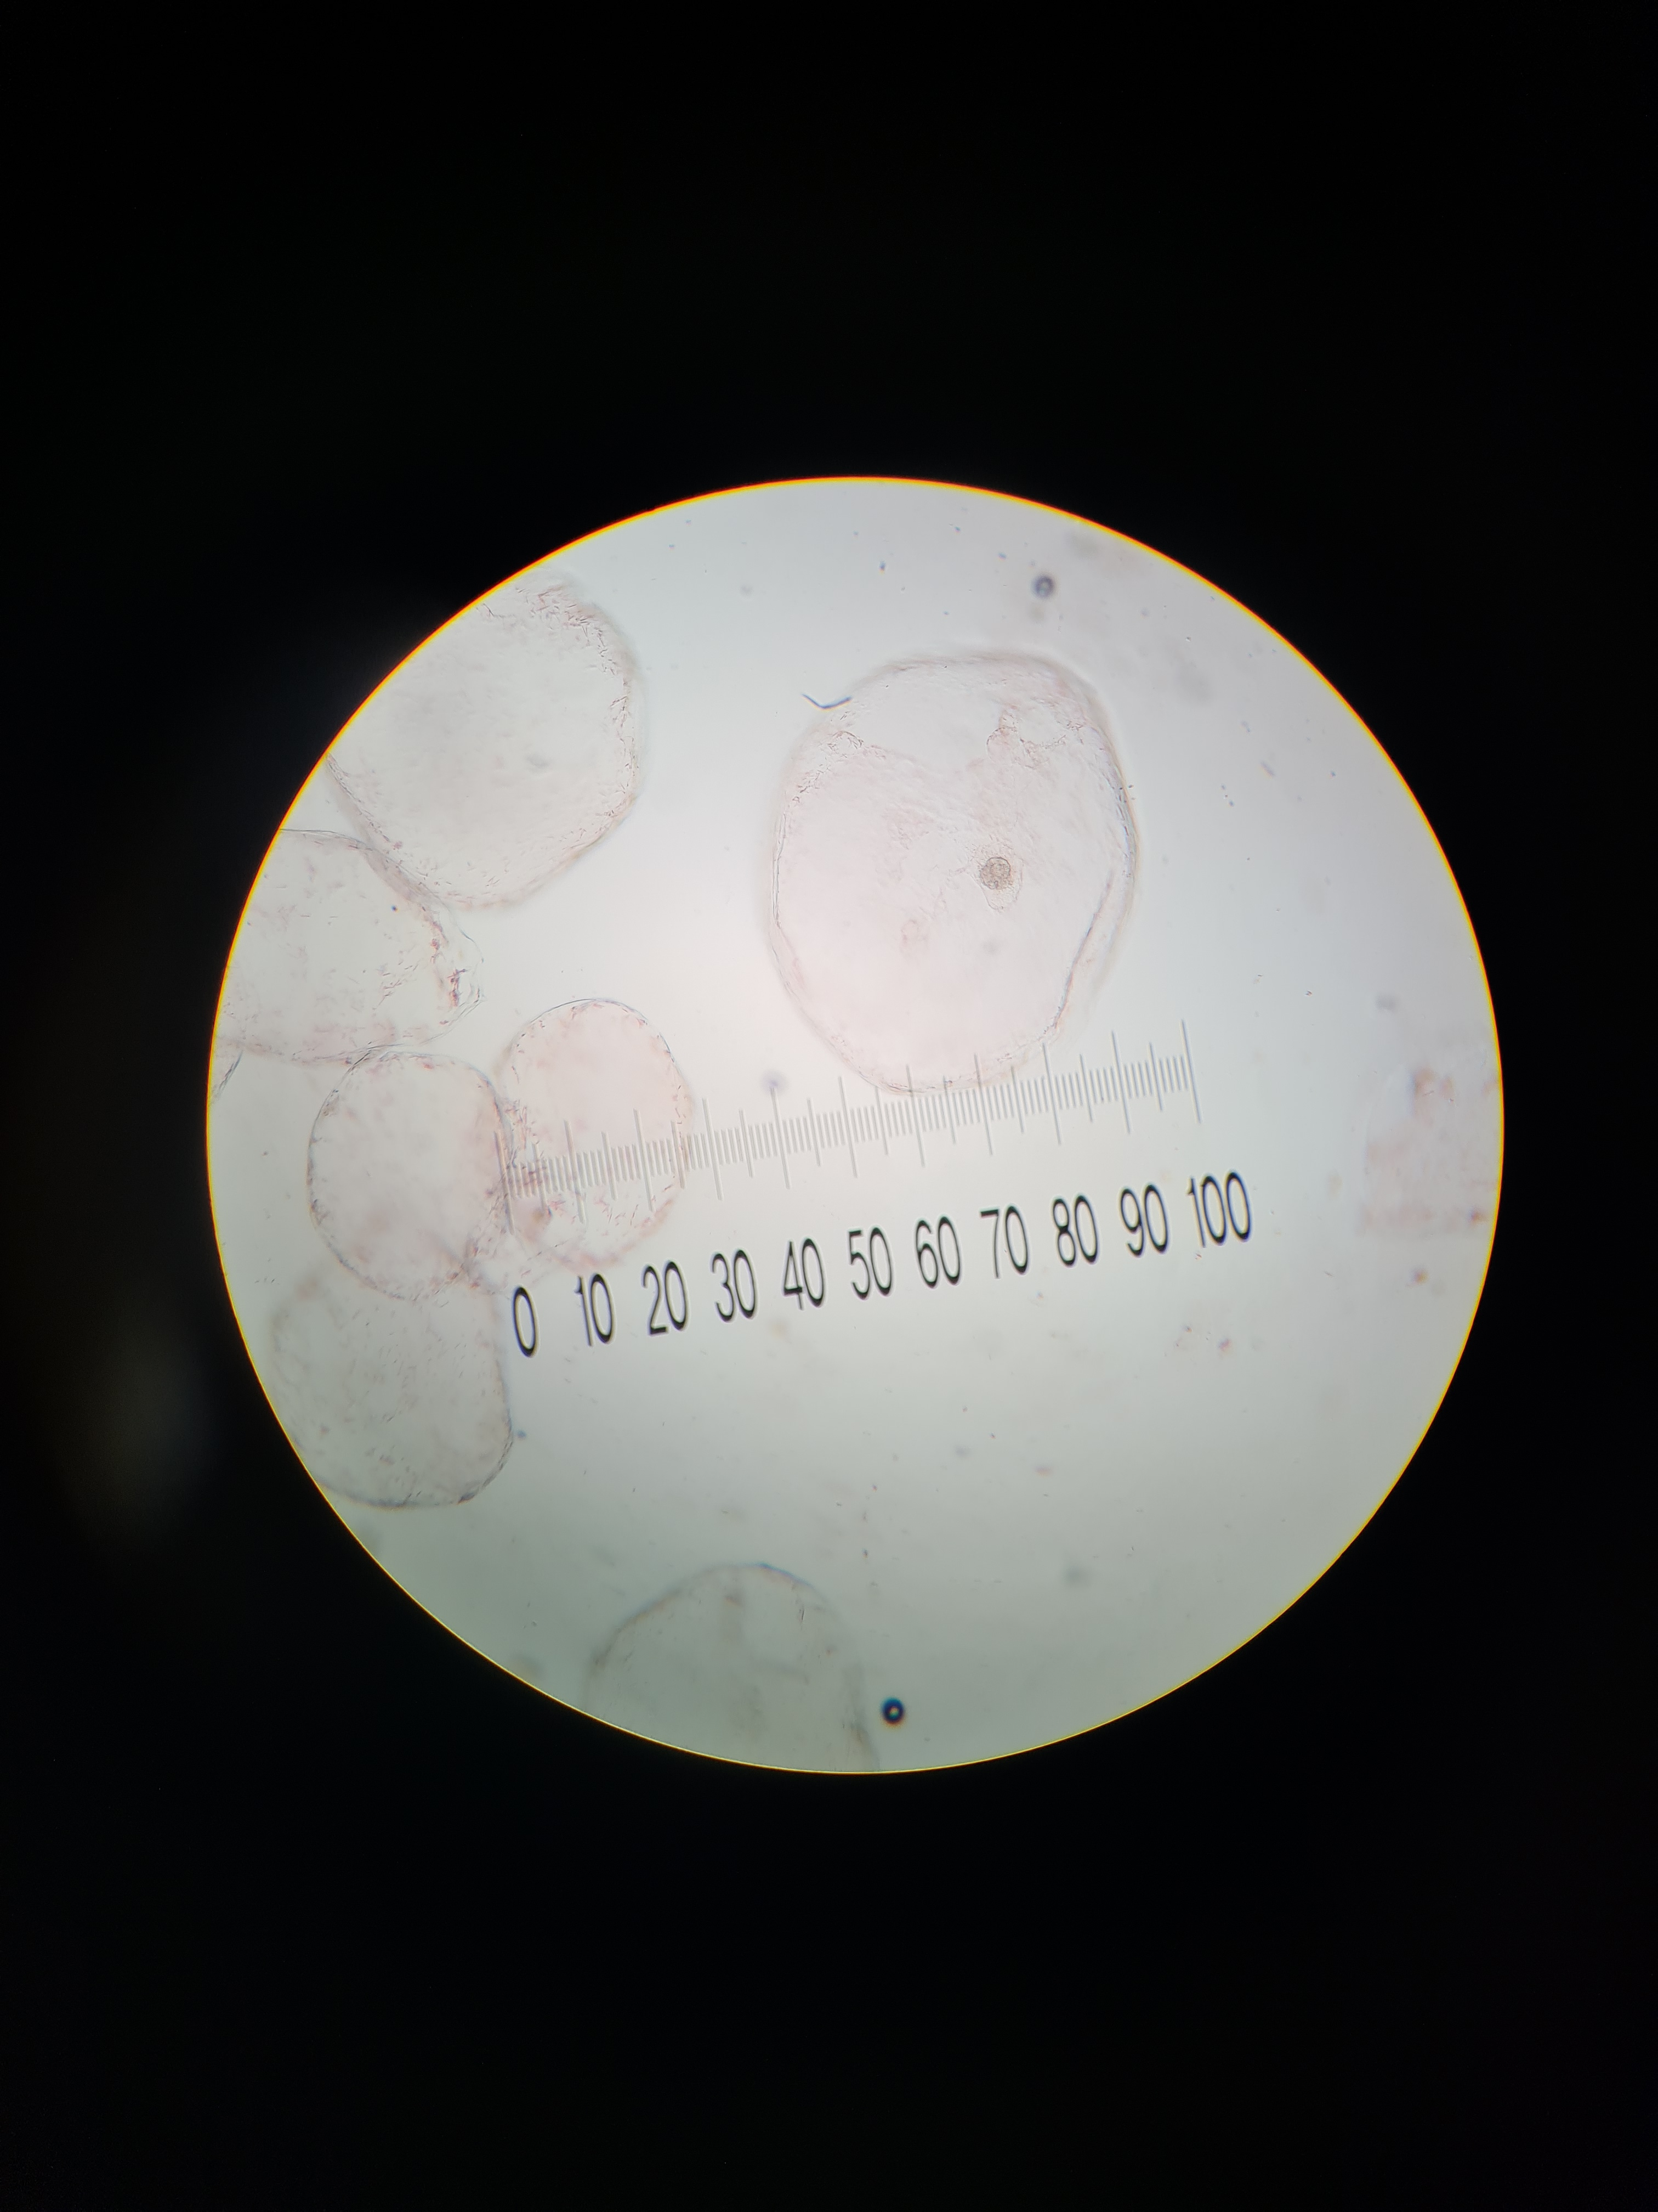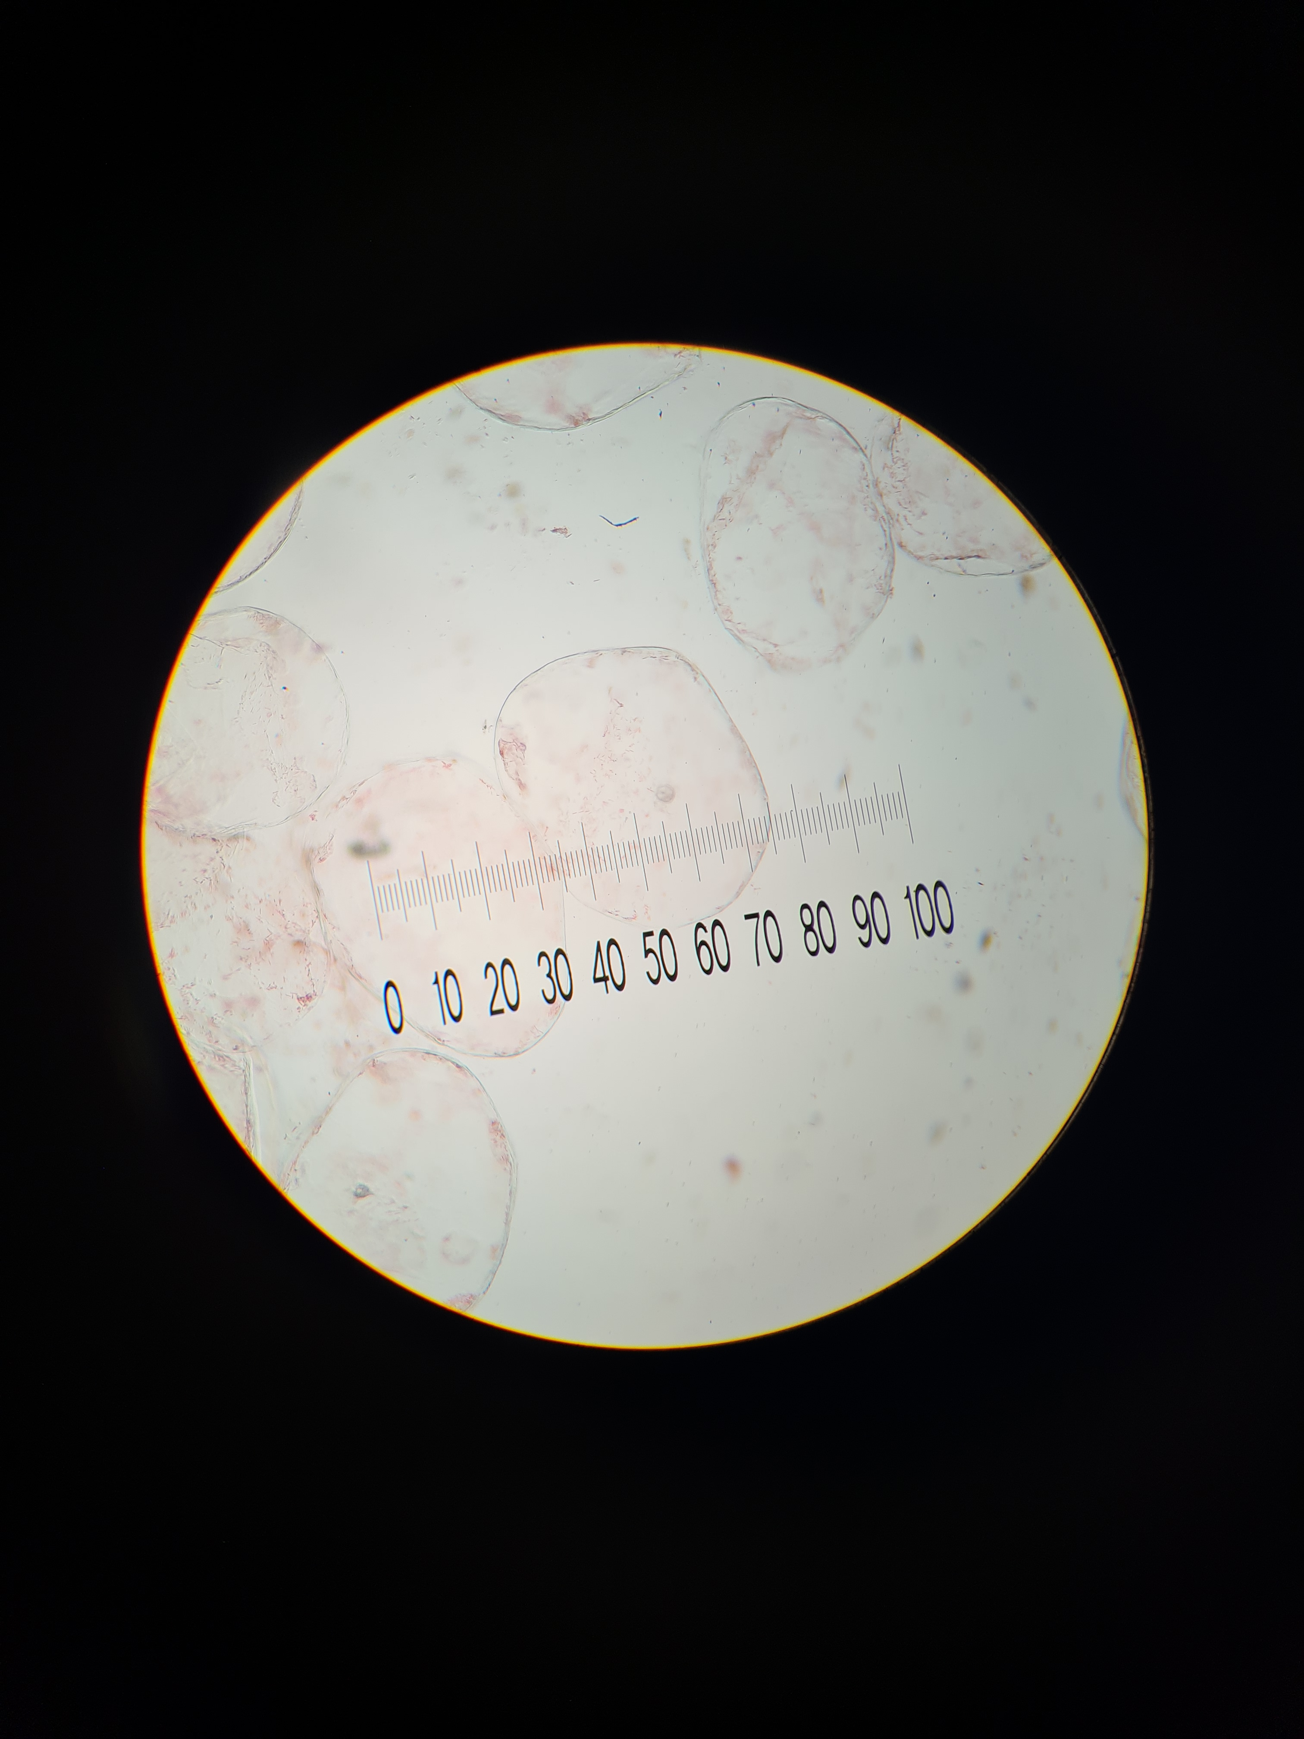

(iii) An eyepiece graticule scale can be used to measure the length of cells. To obtain an actual length, the graticule scale must be calibrated against a stage micrometer.

However, to obtain values for calculating a ratio, it is not necessary to calibrate the eyepiece graticule scale.

Observe the cells of specimen F using the low power (x10) objective lens of your microscope.

Use the eyepiece graticule scale to find

- the width of the largest organelle in the cell
- the width of the cell

State the ratio between the width of the largest organelle and the cell.

You may lose marks if you do not show all the steps in finding the ratio.

Width of nucleus/largest organelle = 2 – 5 ocular graticule units/divisions
Width of the cell = 20 – 50 ocular graticule units/divisions;;

Ratio of width of nucleus to cell is ________;

- Shows measurements for both nucleus and cell – measurements should not exceed 100 ocular graticule divisions AND correct description;
- Precision of measurement as whole numbers for ocular graticule divisions;
- Presentation of ratio to the lowest common denominator and correct calculation;

 | Ratio |  | [3]

(a) (iv) Changes occur to specimen F as it undergoes the ripening process.

A student suggested the hypothesis:

A ripe specimen F contains more reducing sugars than the unripe version.

Explain why the student suggested this hypothesis.

Unripe specimen F stores starch and as it ripens, the stored starch is converted
to reducing sugars;  @ 1m | [1]

(v) You are provided with

- 5 cm³ of an extract made from unripe specimen F, in a vial labelled U
- 5 cm³ of an extract made from ripe specimen F, in a vial labelled R
- 5 cm³ of Benedict’s solution, in a vial labelled B

Using the test tubes and the other apparatus available, plan and carry out a method to obtain results to test the student’s hypothesis.

Outline the steps in your method that you used to collect results.

- To 1cm³ of U in a test tube, add 1cm³ of Benedict's solution and mix well;
(maximum volume used is 2.5 cm³)
- Heat in a boiling water bath for 3 minutes (fixed timing: min 3, max 5 mins);
- Observe colour change and repeat the procedure for R / Record time taken for first colour change to be observed;
R! measuring mass of ppt  -1m if method is not applied to both samples @ 1m | [3]

(vi) Record your results in a suitable format in the space provided. [3]

Specimen | Observations | Conclusions
U | The mixture remains blue | Reducing sugars are absent
R | Brick red/orange ppt is formed | Large / moderate amount of reducing sugars are present

Specimen | Time taken for first colour change / s
U | More than 180
R | 30 (less than or equal to 60)

- Table layout + appropriate column headings
R! tube/vial;
- Complete set of data (observations and conclusions phrased correctly) / time recorded in whole number for seconds;
- Correct trend;

- S1 is a slide of a stained transverse section through a stem of a water plant.

You are not expected to be familiar with this specimen.

Examine S1 carefully using the low power objective lens of your microscope.

Fig. 2.2 is a photomicrograph of a stained transverse section through a different plant stem.

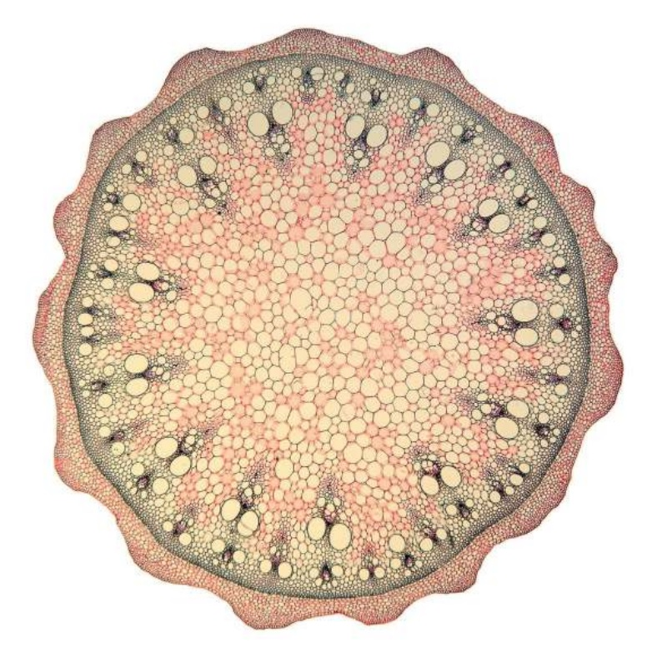

Fig. 2.2

Prepare the space below so that it is suitable for you to record observable differences between the specimen on S1 and Fig. 2.2. Record your observations in the space that you have prepared.

Basis of Comparison | S1 | Fig. 2.2
- Airspaces | present | absent
- Arrangement of vascular tissues  A! vascular bundle | centrally located | Located at the periphery/edge
- Arrangement of vascular tissues | Not in a ring | Found in (2) ring(s) on the periphery
- Thickness of outermost layer | Thin | Thick
- Texture of outermost layer | Smooth/Non-wavy  R! circular, spherical | Wavy/Toothed
- *Organised as table with clear basis of comparison;
*compulsory point

[3]

- Fig. 2.3 is a photomicrograph of a stained transverse section of part of a leaf from another plant. A grid has been placed over the photomicrograph to help you answer the question. Each square is 1 cm².

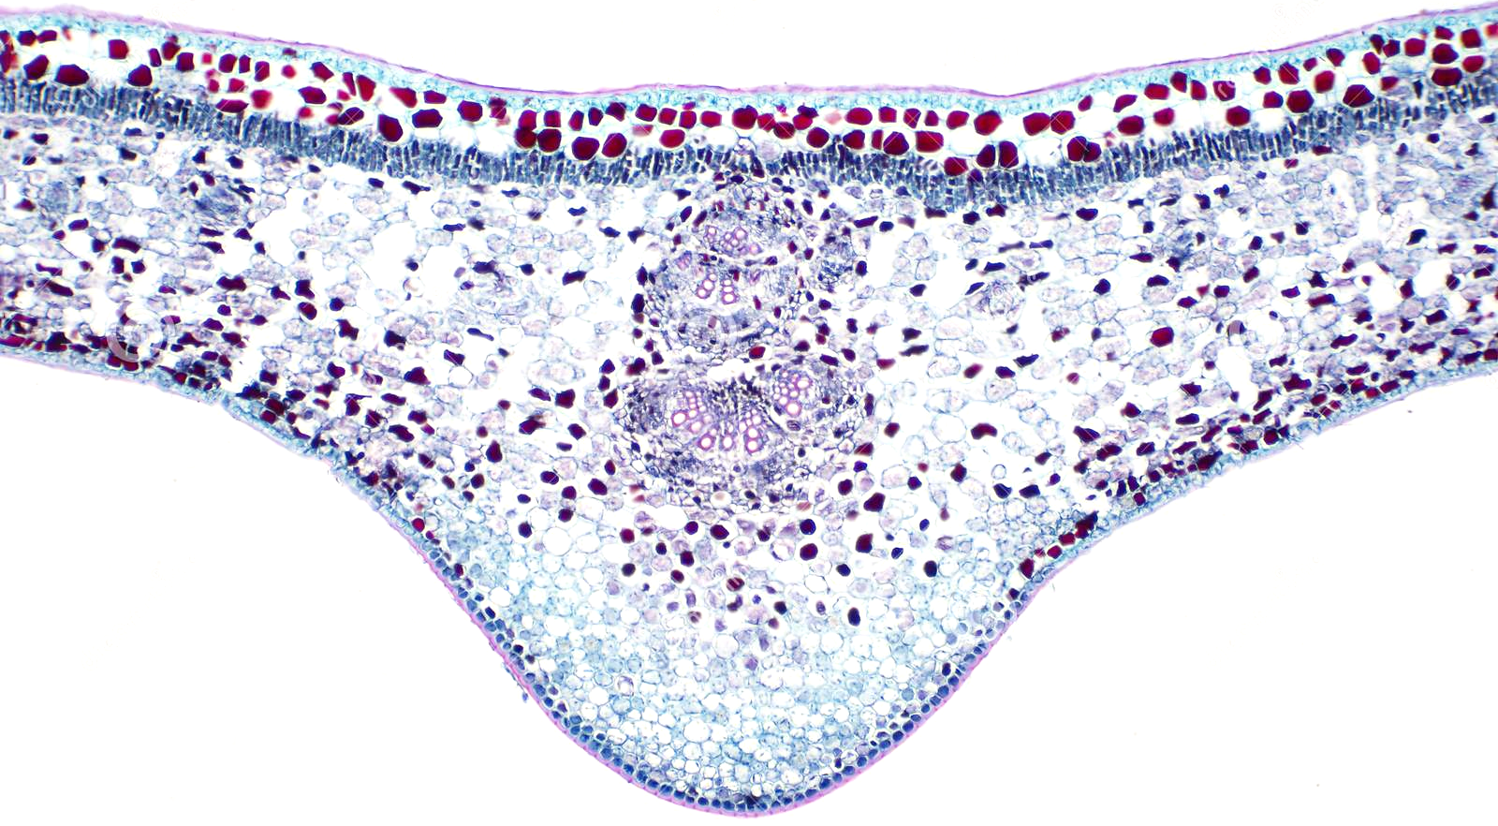
Z

Fig. 2.3

(i) Describe how you will use the grid to find the total area of the part of leaf shown in Fig. 2.3.

Count the number of squares with half or more than its area covered by leaf region;
R! students mentioning combining squares with less than half area covered  @ 1m | [1]

(ii) Use the procedure you have described in (c)(i) to find:

the total area of the part of the leaf shown in Fig. 2.3 | 22 - 26 | cm²
the area of the leaf section occupied by the vascular bundle, labelled Z | 2 | cm²
[2]

(iii) Calculate the percentage of the part of the leaf shown in Fig. 2.3 that is occupied by the vascular bundle, labelled Z.

Show all the steps of your working.

Percentage of leaf occupied = 2/24 x 100% = 8.3%

- Correct calculation;
- Answer to 1 significant figure / 2 sf / whole number;

% [2]

(iv) Suggest how you could modify the procedure you have used in (c)(i) to give a more accurate estimate of the area of the leaf.

Use a grid with squares of area less than 1 cm²;
@ 1m | [1]

[Total: 27]

Experiment No.: Prelim Practical Question 1

Material | Per Student | Per Bench | Per Lab
Ethanol in a covered vial labelled E | 15 cm³
20% glucose solution labelled G  (see Preparation of Materials) | 60 cm³
10% yeast suspension labelled Y | 60 cm³
100cm³ beaker labelled W | 1
Universal Indicator paper strip (pH 1 to pH 14) provided in a small transparent bag | 12 pieces
Colour chart (laminated) | 1
Boiling tubes | 5
10cm³ syringes | 3
600cm³ beaker - 1 glass and 1 plastic  (Used in Q2) | 2
Distilled water, in a bottle | 1
Thermometer | 1
Stopwatch (used in Q2) | 1
Clean white tile (used in Q2) | 1
Dropper (used in Q2) | 2
Glass rod (used in Q2) | 1
Test-tube rack (used in Q2) | 1
Marker Pen (used in Q2) | 1
Paper Towel / Toilet roll | 1
Access to warm water (90⁰C) |  |  | 1

Preparation of Materials

- This is prepared by adding 20 g of glucose to 50 cm³ warm distilled water, stirring and then making up to 100cm³. The glucose solution should be provided to candidates in beakers, labelled G.
- Fresh E, G and Y must be provided for each candidate.
- Yeast suspension should be prepared 60 minutes before the start of the experiment.

Note: Only E, G, Y and Universal indicator paper strips are replaced every shift.

Experiment No.: Prelim Practical Question 2

Material | Per Student | Per Bench | Per Lab
20% glucose solution in vial labelled R | 5 cm³
Distilled water in vial labelled U | 5 cm³
Benedict’s solution in vial labelled B | 5 cm³
Red cherry tomato | 1
Slide S1 |  | 1
Microscope |  | 1
Microscope glass slide and cover slip | 1
Mounting needle
Petri dish | 1
Knife | 1
Test tubes | 2
Sharp forceps | 1
White tile (used in Q1) | 1
600cm³ beaker (used in Q1) | 1
Dropper (Used in Q1) | 3
Test-tube rack (used in Q2) | 1
Bunsen burner, lighter, gauze and tripod | 1
Access to warm water (90⁰C) |  |  | 1
Safety Goggles (at teacher’s bench) |  |  | 20

Preparation of Materials

- 20% glucose solution same as Question 1

Note: Only R, U and cherry tomatoes are replaced every shift.
Safety Goggles to be placed at teacher’s bench.

